Handout no. 7

|  |  |
| --- | --- |
| **Name** |  |
| **Reg. No** |  |
| **Marks/Grade** |  |

**EXPERIMENT NO. 7**

**Perform Unit Commitment operation for selection of Generators by Dynamic Programming**

**Objective:**

At the end of this lab session students will be able

* To accurately perform operation of unit commitment for selection of generators that generate electricity economically by dynamic programming.

**Introduction:**

**Function of Dynamic Programming:**

**Results of Dynamic Programming:**

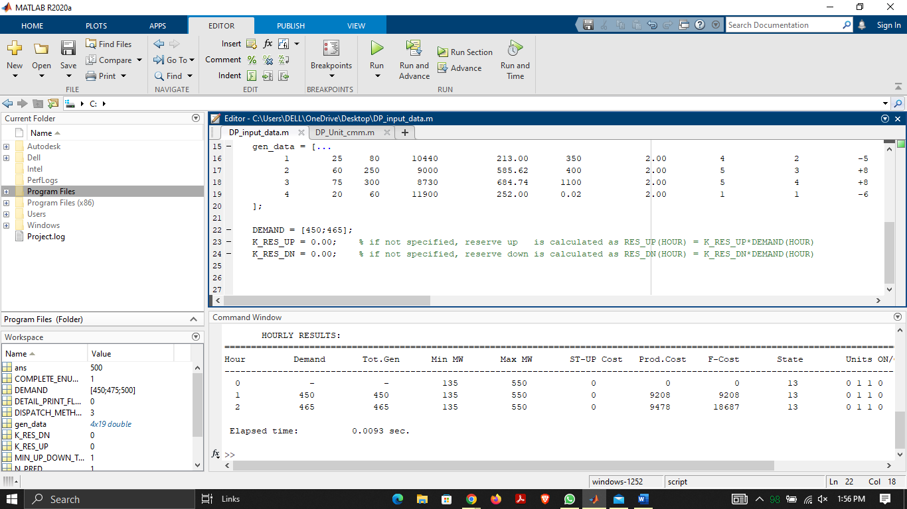

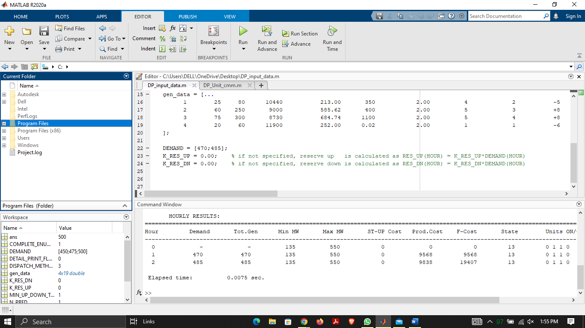

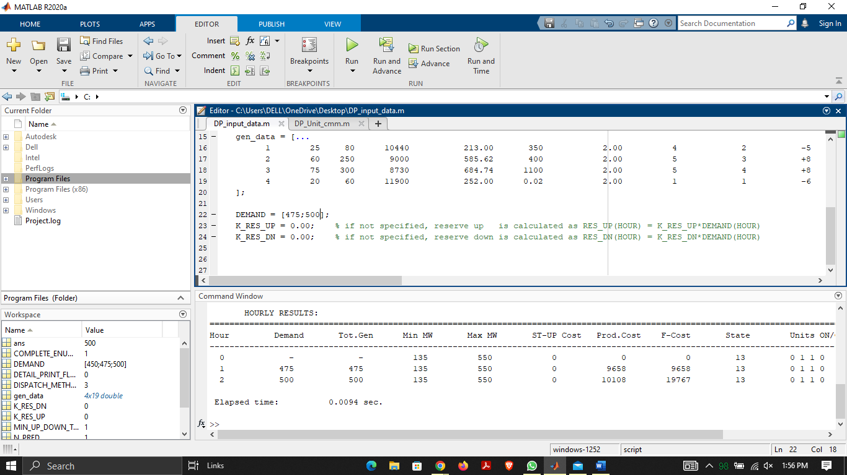

**Observation and Conclusion:**